MOTHER CATHERINE ACADEMY FUNDRAISER
SUNDAY MARCH 25TH 2018
DOORS OPEN NOON GAMES START 1:00
ADMISSION $30.00 AT THE DOOR PRE-PAID $25.00
INCLUDES 16 REGULAR GAMES AND 6 SPECIAL GAMES FOR PURSES
EXTRAS WILL BE SOLD AT THE DOOR AND ON THE FLOOR
4 EARLYBIRD GAMES $50.00 EACH $2.00 EACH OR 3 FOR $5.00
PULL TABS WILL BE SOLD FOR CASH PRIZES
BINGO BOARD WIN A BEAR AND MONEY $100.00 TO $500.00
WE WILL HAVE SPECIAL RAFFLES 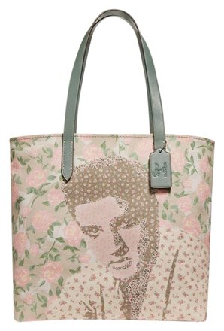ELVIS FOR ONE
FOOD SOLD PIZZA HAMBURGERS HOT DOGS FRIES & DESSERTS
CANDY DRINKS COFFE & SODAS
FOR PRE TICKETS CONTACT SHIRLEY GUY 240-538-5244

